**CLUSTER RESTART PROCESS**

Restarting an Oracle cluster involves several steps. Keep follow these steps can vary based on your specific Oracle Cluster ware and database configurations. Here's a general outline:

1. **Backup Database:** Consider taking a backup of the database before restart.
2. **Status Database Instance**: Use srvctl for check status instance to stop the Oracle database instance running on each node.
3. **Stopping Database Instance**: Use srvctl stop instance to stop the Oracle database instance running on each node.
4. **Stopping Clusterware**: Use crsctl stop crs to stop Oracle Clusterware on the node.
5. **Starting Clusterware**: Use crsctl start crs to start Oracle Clusterware on the node.
6. **Starting Database Instance**: Use srvctl start instance to start the database instance on the node.

1. **Check Cluster Status:**

   - Use cluster management tools (like `crsctl` for Oracle Clusterware) to check the current status of the cluster resources.

  crsctl status resource -t

2. **Check Database Instances Status:**

- Use Oracle Database tools (like SQL*Plus or SRVCTL) to connect to the database.

srvctl status database -d <DB Name>;

3. **Stop Database Instances:**

   - Use Oracle Database tools (like SQL*Plus or SRVCTL) to connect to the database.

   - Shut down all database instances gracefully using the `SHUTDOWN` command.

srvctl stop database -d <DB Name>;

srvctl status database -d <DB Name>;

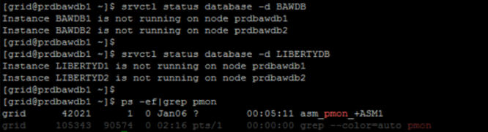

4. **Stop Cluster Services:**

   - Use `crsctl` or other relevant tools to stop Oracle Clusterware services.

   - Ensure that all cluster services are stopped.

  crsctl check crs;

crsctl stop crs;

after that check status………

……………..crsctl status resource -t

5. **Verify Processes:**

   - Confirm that all Oracle-related processes are terminated. This is crucial to ensure a clean restart.

5. **Start Cluster Services:**

   - Use `crsctl` or relevant tools to start Oracle Clusterware services in ROOT user only.

  crsctl start crs;

6. **Verify Cluster Resources:**

   - Check the status of cluster resources using `crsctl status resource -t`.

   - Confirm that all resources are online and in their desired state.

  crsctl status resource -t

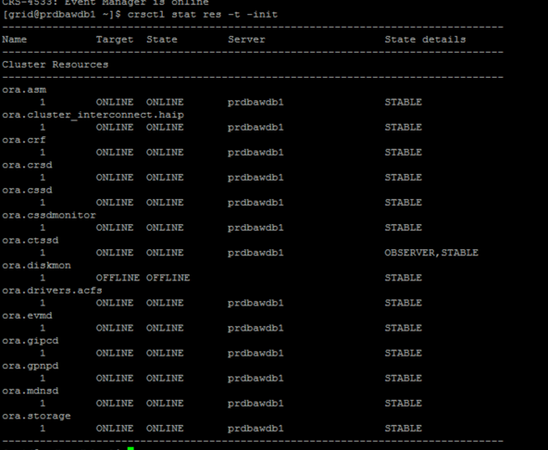

7. **Start Database Instances:**

   - Start the Oracle database instances using the appropriate commands or tools.

  srvctl start database -d <DB Name>;

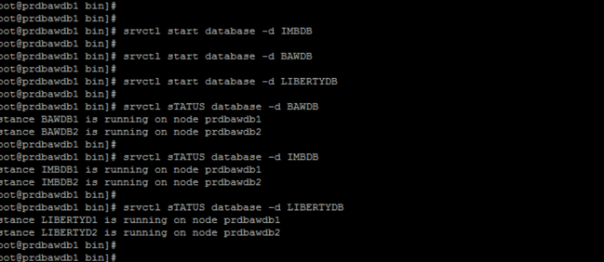

Use Oracle Database tools (like SQL*Plus or SRVCTL) to connect to the database.

8. **Start Database services:**

   - Start the Oracle database services using the appropriate commands or tools.

srvctl start service -d <DB Name>;

9. **Verify Database Status:**

   - Connect to the database and verify that it is open and available.

   - Run queries to ensure that all required tablespaces and components are online.

10. **Perform Functional Testing:**

   - Execute basic database operations to ensure that the database is functioning correctly.

   - Check application connectivity and run some test transactions.

11. **Review Logs and Alerts:**

    - Examine Oracle Clusterware logs, database alert logs, and listener logs for any errors or warnings.

    - Address any issues that may have occurred during the restart process.

12. **Backup:**

    - Consider taking a backup of the database after a successful restart.